Official league roster - Basketball

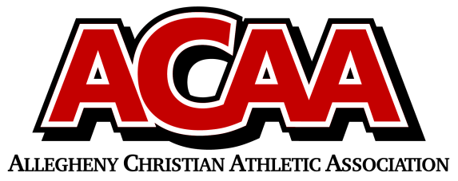
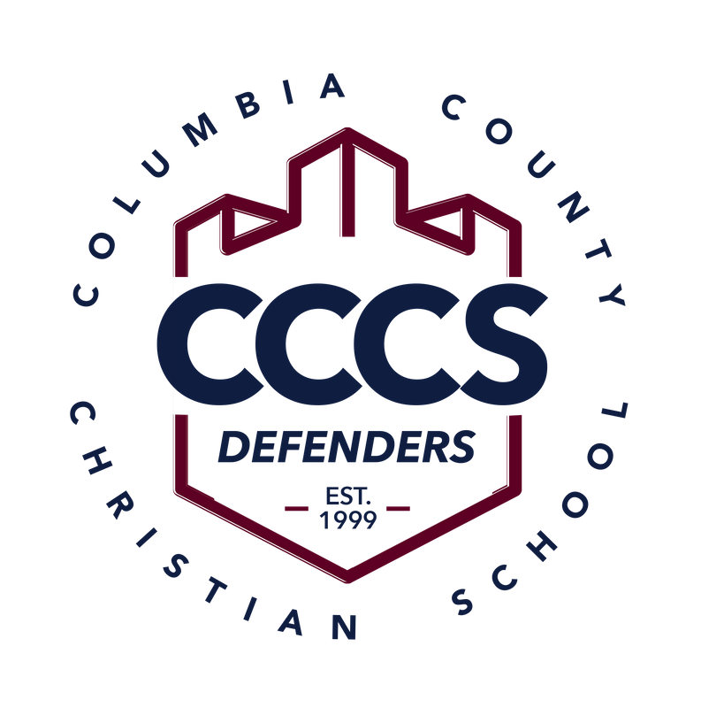

Columbia County Christian School
Team Colors: Navy Blue and Maroon
Overall Wins ___ Losses ____ Ties ___
ACAA Wins ___ Losses ____ Ties ___ OPPONENT: __________________________
Date: _________
Number | Name | Year | Position | Height
24 | Sharyf Conklin | 12 | F | 6’- 0”
4 | Owen Lenker | 12 | G | 5’ – 9”
25 | Jayden Conklin | 10 | F | 6’- 2”
3 | Pierce Cughan | 10 | G | 6’- 3”
5 | Alex Kelly | 10 | G | 5’- 8”
2 | Eli Lenker | 10 | G | 5’- 9”
21 | Noah Levan | 10 | F | 5’ – 8”
15 | Noah Massey | 10 | F | 5’ -9”
10 | Judah Farley | 8 | G | 5’ – 6”
11 | Emmett Scheirer | 8 | G | 5’- 8”

Head Coach: Jim Cughan
Asst. coach: John Nacional
Backup Assistants: Aaron Kline,
Tori Boudman

